Dutch Vintage Ads for Russian Cams
September 28, 2008

"swieconek":http://beta.lomography.com/homes/swieconek from the community visited a fleamarket some time ago in Bruges, Belgium and came across some real vintage goodies: A store booklet containing original Dutch ads for Russian cameras in their youth (1968)!
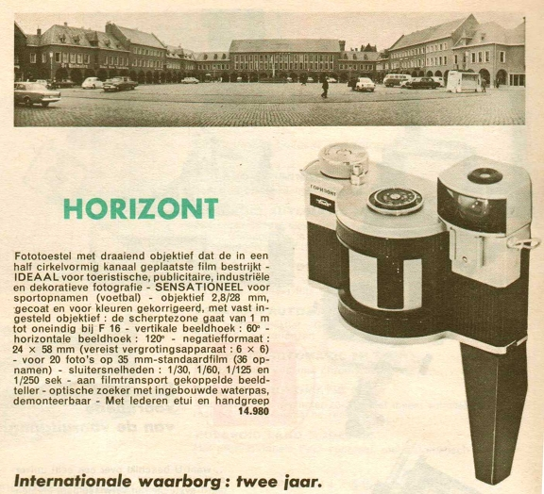
Horizion
- Camera with turnable lens, that illuminates a film, that is placed in half a cirkel.
- Ideal for touristism, advertisings, industrial and decorative photography.
- Sensational for sportphotography (football).
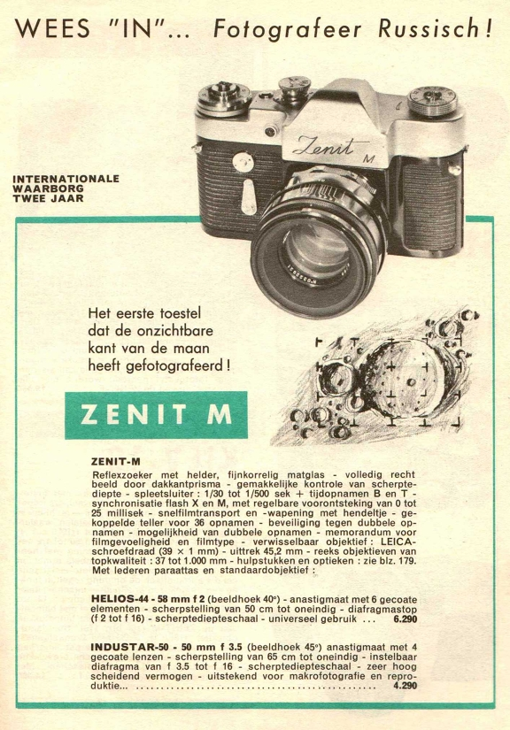
Zenit-m
- Be “Inn”, use Russian cameras for photography.
- The first camera that took pictures from the unknown side of the moon.
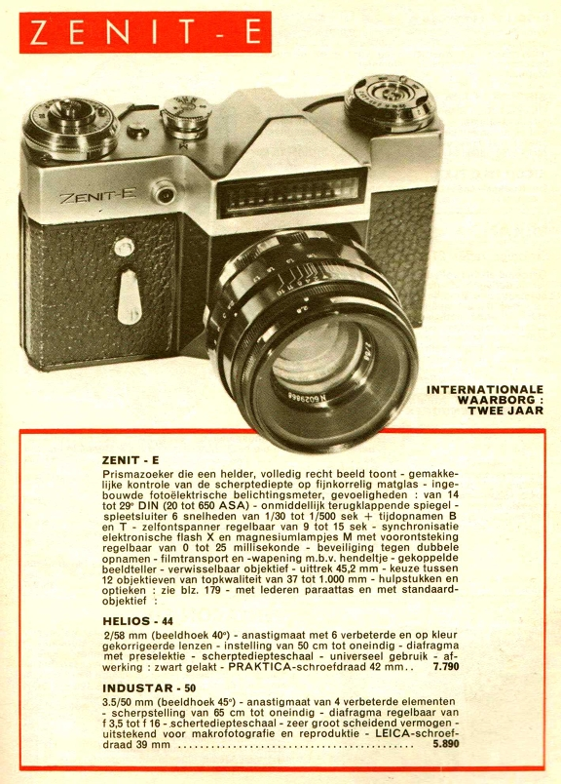

Zenit-e
- Clear prisma-viewer that shows a completly straight image, with the sandy mirror you can easily controle the sharpness. The mirror claps directly back. There is a pre-warming to use magnesiumflashes. Security-lock against doubles. The filmtransport is coupled with the picturecounter and rearming.

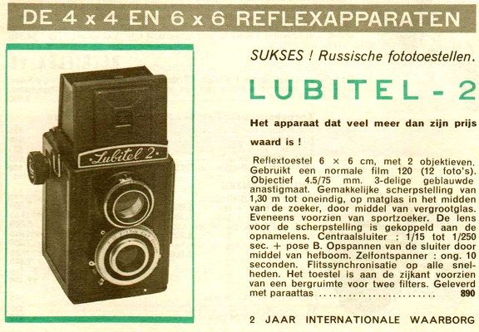
Lubitel
- Good luck with Russian camera.
- The camera that is more then only his price.
- The camera has 2 lenses, with his 4.5/75 blued anastigmat.
- Easy focusing, use the matglass in the middle of the viewer with magnifier. Also with sportviewer.
- There is place on a side o the camera to hold 2 filters
- camera to hold 2 filters.
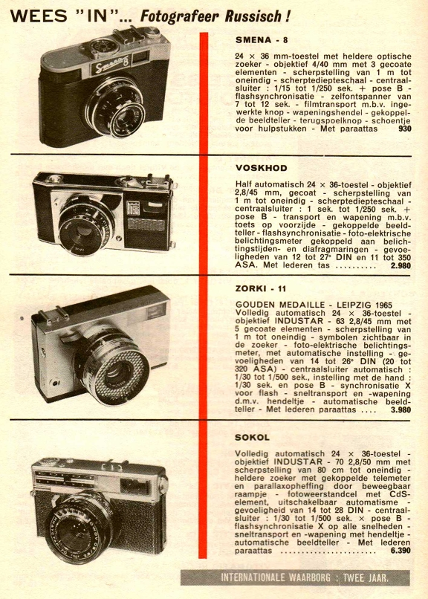
Smena
- The camera has a inner button for the film-transport, an arming-device, a coupled picture-counter, a rewind-mechanism, a hot shoe and is delivered with a ready-to-go bag.

written by lucasjakobsson

xxxxxxxxxxxxxxxxxx

